

From the formula that

$${(k}_{1}{+k}_{2})\dot{B}+k_{1}k_{2}B≥0$$

If $k_{1}$ is too small, then the whole constrain will not be such sensitive, which means that only if robot is much closer to the obstacles, the CBF function can come into play.

From the figure that the more $k_{1}$ is, the trajectory has more distance from the obstacle, which means that the forward-invariant set is smaller and more conservative. When $k_{1}$ is 1, the robot cannot adjust its brake to drive itself away and it will go through it, which can be the problem result in robot crash. As to the forward-invariant set, it will contain more the chosen of robot’s trajectory which are high risky and closer to the border of obstacles.

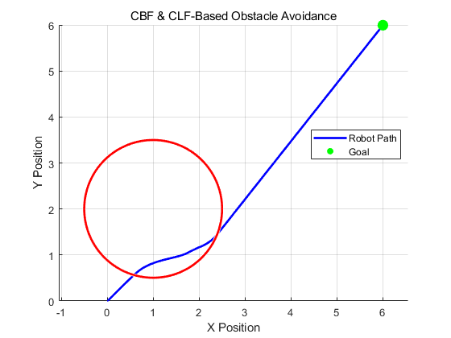

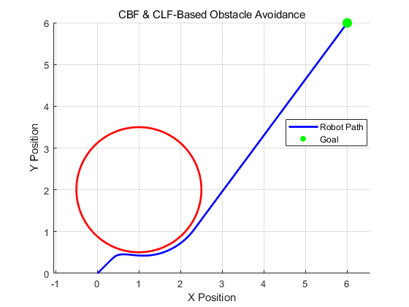

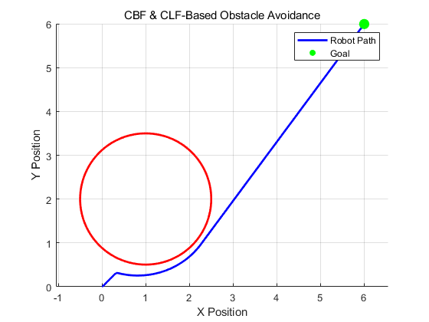



文本, 信件

AI 生成的内容可能不正确。

More penalty p will lead the robot trajectory more stick to the obstacles shape.

Gama 1 will affect the speed of convergence.